Facilitating the emotional mapping exercise

Listen to the interviews and pick out the key moments along the patients’ experience of their journey – moments raised by a number of patients. Write those moments down on pieces of paper constructed into a long, straight line on a wall – much like a process map.
Then, ask the patients to approach the wall wherever they want to, look at those moments, and raise the position of that piece of paper if it was a positive moment or lower it if it was negative.
Next, ask the patients to write words on sticky notes to describe the emotions they associate with each of the moments. Again, people can begin with whichever element of the journey they wish to and carry on until they have said as much as they wish to about their overall journey.
Once everyone has contributed all they wish to the map, lead the group in looking at the map as a whole. Look in particular at aspects that attract a range of views and those where there are many comments, whether positive or negative.
This tool highlights those moments or aspects of the service that could be handled better.
Discuss the map and help the group narrow the points down to four or five areas for improvement to be taken to the joint patient–staff event.

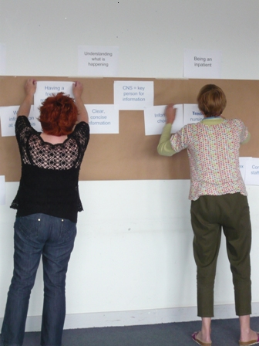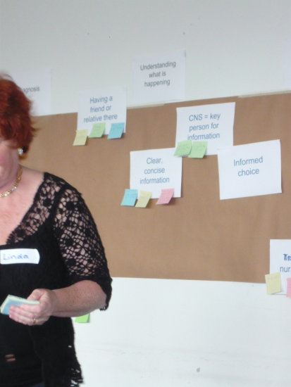
Example of emotional mapping touch points – lung cancer

Receiving the diagnosis
How you were told you had lung cancer
Support and information at time of diagnosis

Moving through the service
Waiting for results
Delays in starting treatment
Speed of moving through the service
Seeing lots of different doctors
Seeing more than one clinical nurse specialist
Waiting times in clinics
Transfer from one hospital to another

Being an inpatient
Attitudes of nurses on the ward
Staff available when needed on the ward
Communication on the ward
Mixed-ward experience
Going to theatre

Having chemotherapy
Chemotherapy day unit experience
Staff available when needed on chemotherapy unit
Staff attitudes

Having radiotherapy
Radiotherapy department environment
Radiotherapy staff
Music played during radiotherapy

Understanding what’s happening
Information about patient journey – who you would see, when, where and why
Information about treatments
Information about what to expect after treatment
Information about home care
Information about financial benefits
Patient Information Centre

Receiving support
Clinical nurse specialist support
Psychological support
Support from other patients

